CRYOSMOS

WP200
Scientific Review and Case Studies Consolidation
PART 2
WP220 – Case Studies Consolidation

Case Study Consolidation Report (CSC)

Version 1.1
April 2nd 2015







This page is intentionally left blank

ESA STUDY CONTRACT REPORT
ESRIN Contract No:  4000112262/14/I-NB | Subject:  CryoSMOS  Support To Science Elements SMOS+Cryosphere |  |  | Contractor:  IFAC
ESA CR ( )No: | Star Code: | No of volumes: 1  This is volume no: 1 |  | Contractor’s Ref:  Deliverable D2
ABSTRACT:
This is the Task 1 Report (Deliverable D2) of the study CryoSMOS - Support To Science Elements SMOS+Cryosphere (ESRIN Contract No. 4000112262/14/I-NB). It contains the detailed description of the proposed Case Studies to be used in the project.
The work described in this report was done under ESA Contract. Responsibility for the contents resides in the author or organization that prepared it.
PREPARED BY:
G. Macelloni, M. Brogioni, (IFAC), N. Skou, R. Forsberg (DTU), M. Leduc-Leballeur, G. Picard (LGGE), L. Kaleschke, A. Wernecke (UHAM), A. Mialon (CESBIO)
ESA STUDY MANAGER:  Ola Grabak |  |  | ESA BUDGET HEADING

This page is intentionally left blank

DOCUMENT CHANGE LOG
Issue/  Revision | Date | Observations
1/0 | 02/04/2015 | First issue
1/1 | 25/06/2015 | English grammar improved

This page is intentionally left blank

TABLE OF CONTENTS

1.1 Purpose 10
1.2 Document Structure 10
1.3 Definitions and Acronyms 11
1.4 Reference documents 12
2 The potential of SMOS for Cryosphere research over ice sheets. 14
2.1 Context of SMOS and the ice sheet/shelves 14
2.2 Case Studies 15
3 Case study n.1: quantifying internal ice-sheet temperature 18
3.1 Scientific challenge and requirements 18
3.2 The retrieval of ice-sheet temperature profile: test areas, data and methodologies 20
3.2.1 Test areas, available data and models 20
3.2.2 Methodology used for the ice sheet temperature profile estimation 22
3.3 Potential constrains 23
4 Case study n.2: bedrock topography and/or geothermal heat flux 24
4.1 Scientific challenge and requirements 24
4.2 The retrieval of bedrock topography and/or geothermal heat flux: test areas, data and methodologies 25
4.2.1 Background 25
4.2.2 Methodology 30
4.3 Potential constrains 31
5 Case study n.3: characterization of ice shelves 32
5.1 Scientific challenge and requirements 32
5.2 The characterization of ice shelves: test areas, data and methodologies 33
6 Case study n.4: characterization of surface processes 38
6.1 Scientific challenge and requirements 38
6.2 The characterization of surface processes: test areas, data and methodologies 39
6.3 Potential constrains 41
7 References 42

This page is intentionally left blank

1. Purpose and structure of document

Purpose
This document is the Case Studies Consolidation (CSC) report for the CRYOSMOS project. Its purpose is the detailed description of the case studies to be used in the project. The selection of the case studies has been performed on the basis of the review carried out in WP210 by considering the potential of the SMOS TB observations for each geophysical parameter, its relevance to the scientific community and the availability of suitable models and data to perform the retrieval.
In the following sections the case studies are detailed, as well as the methodologies to be used in the prosecution of the project, the auxiliary data necessary for the retrieval of the ice sheet/shelves properties and the areas which will be under investigations. Also, the potential constrains for each case studies are highlighted.

Document Structure
The structure of the document is the following (and summarized in Table 2-1 against WPs):
- Section 2 - Overall comprehensive view of the potential of SMOS for Cryosphere research over ice sheets.
- Section 3 – 6 Description of the scientific challenge faced for each of the case studies pointing out the test areas, available data, models to be used, methodological approaches, experiments and techniques to be used, developed and implemented for the estimation of the geophysical parameter.
- Section 7 - References

Table 2-1 - Structure of document against subtasks of the work package
WP | subtask | section(s) in this document | main contributors
220 | 1, 2 | 2 | All
220 | 3-7 | 3-6 | All

Definitions and Acronyms

Table 2-2 lists the acronyms and abbreviations used within this documents.

Table 2-2: Acronyms and abbreviations
Acronym | Meaning
AMSR-E | Advanced Microwave Scanning Radiometer for EO
AMSR-2 | Advanced Microwave Scanning Radiometer
AMSU | Advanced Microwave Sounding Unit
BT | Brightness Temperature
CEOS-WGCV | Committee on Earth Observation Satellites-Working Group Calibration and Validation
CESBIO | Centre d'Etudes Spatiales de la BIOsphère
CSCR | Case Studies Consolidation Report
DMRT | Dense Media Radiative Transfer model
DTU | Danish Technical University
ECV | Essential Climate Variables
EM | ElectroMagnetic
EO | Earth Observation
EOEP | Earth Observation Envelope Program
EPICA | European Project for Ice Coring in Antarctica
ESA | European Space Agency
GOCE | Gravity field and steady-state Ocean Circulation Explorer
IFAC | Istituto di Fisica Applicata “N.Carrara”
IR | InfraRed
ITT | Invitation To Tender
LGGE | Laboratoire de Glaciologie et Géophysique de l’Environnement
MODIS | Moderate Resolution Imaging Spectroradiometer
MIRAS | Microwave Imaging Radiometer by Aperture Synthesis
ML | Multi-Layer
NIR | Noise Injection Radiometers
NASA | National Aeronautic and Space Administration
QCA-CP | Quasi Crystalline Approximation with Coherent Potential
RB | Requirement Baseline report
SMAP | Soil Moisture Active and Passive mission
SMOS | Soil Moisture Ocean Salinity mission
SoW | Statement Of Work
SSM/I | Special Sensor Microwave Imager
STSE | Support To Science Elements
TB | Brightness Temperature
UHAM | University of Hamburg
WALOMIS | Wave Approach for LOw-frequency MIcrowave emission in Snow
WP | Work Package

Reference documents
All the references to scientific works cited in the present report are reported in section 7. Hereinafter are listed some general management documents referred in the present report:

[RD.1] Project Statement of Works
[RD.2] CryoSMOS project proposal
[RD.3] D1 - Requirement Baseline report

This page is intentionally left blank

The potential of SMOS for Cryosphere research on ice sheets

Context of SMOS and the ice sheet/shelves

Antarctica is a key element of global climatic system. Its low temperatures (down to -90°C in winter), composition and extension have a vast impact on atmospheric and oceanic circulations, as well as on the Earth’s energy balance. In recent years, considerable changes have been observed across this continent. On the one hand, ice sheet surface temperatures are rapidly rising in West Antarctica and in Peninsula, while they seems to be stable in East Antarctica (e.g. Steig et al., 2009). These studies were based on infrared satellite measurements (which are irregular due to their cloud sensitivity) and on very sparse in-situ data. On the other hand, the warming observed in Antarctica has had and has dramatic consequences on the coastal region. In particular, at present ice shelves (i.e. the floating extension of outlet glaciers) are breaking up while they previously lay undisturbed for at least 10,000 years (Cook and Vaughan, 2010). Several authors have shown that these collapses impact on the glacier dynamics, and thus contribute in rises to sea level (Scambos et al., 2004; Rignot et al., 2011). Therefore, the study of the Antarctic climate requires reliable information on the snow temperatures and firn properties of ice sheet and ice shelves. In addition to the requisites of clearer investigations on the effects of climate changes on the Antarctic continent, there is also a need for better understanding of the geophysical processes taking place there. Indeed, Antarctica dynamics are unique (due to its location, morphology, composition and environmental condition), and are completely different to ones that take place elsewhere.

Because of the sparse coverage of the in situ measurements in Antarctica (Turner et al., 2006) due to the limited possibility of operating in such a harsh environment, remote sensing data are of paramount importance for climate study in this continent. The observations of space-borne sensors are a unique means for providing a detailed picture of the spatial and temporal variations in essential climate variables. Up to now, investigations have been carried out by using optical and microwave satellites. However, due to the frequency bands of the satellite sensors, only the surface of the continent has been extensively investigated. In fact, for a long time (until the launch of ESA SMOS mission) the lowest satellite frequency available was the C-band, which can penetrate the snow for about 50 m. Within this context, SMOS observations have several advantages. Due to the low microwave frequency used (1.4 GHz, i.e. 21 cm wavelength), these observations are sensitive to an higher portion (on the order of 500m) of the ice cap caused by the low snow and ice absorption at L-band. Given the fact that the signal penetration is considerable, the possibility of obtaining information on snow structure on several hundred meters in depth becomes feasible and opens up new research scenarios. Also, since the wavelength is much greater than the dimensions of the snow crystals, the scattering is almost negligible and the emissivity is close to unity when the surface reflection vanishes (i.e. at vertical polarization near the Brewster angle ∼50-60deg), suggesting that the brightness temperature is close to the snow temperature.
Therefore, an exploitation of the SMOS capabilities in order to provide innovative observations, new products and potential future applications to the cryosphere will be very useful in studying the Antarctic ice sheet, including its floating ice shelves.

Case Studies

Due to the structure and climate conditions of Antarctica, our knowledge of its geophysical properties is very limited. Remote sensing techniques and numerical modelling have pushed forward the research on the ice sheet; however, there are several processes which can be only partially estimated because of the extension of the process (e.g. an accurate determination of the mass balance) or the impossibility of direct measurements (e.g. the bedrock heat flow or the dynamics of the liquid water network below the ice caps). As pointed out in the previous section, up to a few years ago, satellites were only able to monitor the ice sheet surface due to their operational bands. Instruments working at frequencies low enough to penetrate the ice down to the bedrock were used only extemporary (e.g. the Radio Echo Sounding – RES are performed only in some very specific places or with the use of airborne P-band SAR) as they did not allow for a continuous monitoring of the geophysical processes. The availability of a satellite sensor that is sensitive to the properties of an appreciable part of the ice cap opens up new scenarios for the characterization of the Antarctic dynamics. The selection of the geophysical processes (hereinafter also referred to as case studies) to be investigating in the project by exploiting SMOS data has not been straightforward, but has dealt with the following issues:
- Each case study must have an appreciable impact on the ice emissivity and/or on its physical temperature in order to be revealed by SMOS measurements. Conversely, the process cannot be observed. For instance, this is the case of the continent’s usual daily snow deposition inland, which does not have any impact on L-band brightness temperatures on a daily or monthly timescale.
- The equivalent SMOS footprint is on the order of 40 km x 40 km. Thus case studies must affect areas of a comparable extension or have an impact on the scenario that is strong enough to modify the SMOS measurement in the footprint area. This implies that highly localized phenomena can barely be monitored by SMOS, if at all.
- The penetration depth of e.m. waves at L-band is less than 1 km in ice. Thus, the case studies to be investigated must influence in some way the ice cap properties in its top part. Otherwise it is not possible to revel them by means of SMOS.
- The case studies must be temporally steady or must undergo to a change that can be appreciable over a time period of a few years (the SMOS lifetime for the past and the project duration for the future). If the process is temporally dynamic over a time-span of decades, it cannot be considered for the present project due to the lack of data.
- The case studies must comply with the requirements [REQ-1]-[REQ-8] of the SoW [RD.1].
- One last point: the SoW [RD.1] indicates the study of “bedrock topography and/or geothermal heat flux” as being mandatory.

Given all of these constraints, we have re-analyzed the literature in order to select any possible gaps in the knowledge of the ice dynamics that can be filled by using SMOS measurements (at least in part). We have divided the potential topics into groups (namely the surface, internal and bottom/ground of the ice sheet, and ice shelves), and have found some possible physical parameters that can be investigated.
The state of the surface, i.e. its topographical features and the physical properties of snow in proximity to the surface (grain size, wetness, density), is important to an understanding and prediction the surface energy and mass budgets, which are two key nivo-meterological variables of interest for the study of climate and of the potential contribution to sea level rising. Variations in near surface snow dielectric properties affect radiometric observations, thus providing the possibility of retrieving information about the surface state. Despite the great penetration depth of L-band radiation, snow property changes near the surface (up to one wavelength deep) can impact on SMOS observations. Within this context, an analysis of SMOS observations may provide information about the state of the surface, such as melt events, crust ice, variations in roughness, etc.
As regardr the internal part of the ice sheet, a major unknown is represented by the actual temperature profile. As reported in several papers and books, the dynamics which lead to a given ice temperature distribution are fairly clear and are well-described by thermodynamics laws. However, a determination of the actual temperature profile by using only theoretical approaches is very difficult, since the internal properties of the ice sheet are not completely known (or they are estimated without sufficient accuracy). In this context, brightness temperature measurements at L-band are very valuable for estimating the temperature profile, since they can probe an appreciable part of the ice cap thickness (around 20%-30% in the plateau region), thus providing very useful information. Our review of the literature has also pointed out other geophysical processes that need to be investigated, such as the internal movements of the ice masses or to a warming of the interiors layers due to a warming of the climate. Unfortunately, SMOS measurements cannot provide much help due both to the nature of the TB measurement (TB is the sum of all the energy emitted by the target integrated for a given time, and does not make possible analyses such as those of radar signals) and to the time period necessary in order to reveal the phenomenon.

As regards ice shelves, three important properties of theirs are the thickness, the temperatures, and the state of a potential layer of marine ice. They influence the flow characteristics, and can ultimately determine whether an ice shelve will collapse or not. In order to determine those properties, TB measurements at L-band can benefit from the fact that the ice shelf thickness is less than the L-band penetration depth. The ice temperature of the whole column influences the measured brightness temperature: parts of the signal from below the meteorological ice will penetrate it which might make it possible to estimate its thickness. By analyzing this signal, it could possibly become feasible to estimate its origin (marine ice or water). Marine ice consists of platelet ice crystals that have been produced from ocean water and attached to the meteorological ice, thus partly constructing a consolidated ice layer beneath it. It therefore has very distinct electromagnetic properties, somewhere between fresh meteorological ice and the much saltier sea ice. Since marine ice is softer (because it is warmer), it can prevent the opening of crevasses, and in additions fill up existing ones. By doing this, it is altering the roughness that makes it difficult to predict its exact influence on the brightness temperature.
Case study concerning bedrock topography was a requirement of the ITT. Shortly after the DOMECair campaign had been flown and the TB data had beenprocessed, it became clear that there was a good correlation between the measured TB and bedrock topography. Thus, the question soon came up: can SMOS imagery, which covers all of Antarctica, support our present knowledge about bedrock topography, which is not well known all over Antarctica? The work carried out so far, and reported in Section 5, brings the analysis of the correlation between topography and TB one step further, and consolidates the fact that the choice of this case was correct and promising.

Case study n.1: quantifying internal ice-sheet temperature
(IFAC-CNR in cooperation with DTU, LGGE, CESBIO)

Scientific challenge and requirements

The internal temperature is a key parameter for ice sheet dynamics. Indeed, all the processes are related to the temperature profile (and, in turn, influence it): for instance, the ease of the ice internal deformations and the rate at which the ice flows across the base. Thus, a knowledge of it fundamental to a better understanding of the changes in ice sheet mass balance and dynamics. At present, the only information about actual ice sheet internal temperature comes both from the small number of boreholes in which temperature profiles have been directly measured and from climate modeling. However, the drilling of boreholes is a very expensive activity (especially because of the thickness of the ice and the harsh environment), and neither the state of the art climate or glaciological models are unable to determine the temperature profile at continental scale.
A thorough description of the physic of the ice temperature profile can be found in (Van der Veen, 2013) and in (Cuffey and Paterson, 2010). The ice sheet temperature distribution is controlled by several factors, the main ones being the climate (which determines the surface temperature), the geothermal heat, and frictional heating from basal slip (which can warm and if possible melt the base), the ice deformation and meltwater refreezing (which warm the interior), and the mean annual accumulation rate. Moreover, heat is transferred within the ice layers by their movement in three directions: a layer can “move” vertically in the glacier due to the accumulation or ablation of the snow on the surface, but can also be displaced laterally (advection). Thus, the temperature profiles in the ice sheet can differ greatly from one point to another. Examples are given in Cuffey and Paterson (2010) (Figure 3-1) where some measured temperature profiles in ice sheets and ice caps are reported. In Figure 3-1 the name of the borehole drilling site is reported along with the advection parameter as defined in the book. Small numbers indicate negligible advection.
Figure 3-1 – Temperature profiles measured in boreholes of polar ice sheets and caps. The advection parameter is indicated in parenthesis. After Cuffey and Paterson (2010).

Figure 3-1 points out that the temperature profiles depend considerably on the advection parameter. Siple Dome and Bindschadler Ice Stream are very close to each other, but the high flow velocity of the latter strongly modifies the profile.
As pointed out previously, the temperature distribution in the ice sheet depends on several factors, and not all of these are well characterized. The simplest case is the absence of advection (or its negligible presence), which is a typical condition of the ice divides and domes (e.g. Dome C). When the snow accumulation is scarce and constant (the case is also referred to as “steady-state temperature profile”), the temperature is well represented by Robin’s model (Robin, 1955). The latter represents the temperature profile as a function of surface temperature, ice thickness, geothermal heat flux, mean accumulation rate, ice diffusivity and conductivity

(3.1)

and the principal assumptions are that the basal temperature is below the melting point, horizontal heat diffusion is smaller than the vertical one, horizontal velocity of the ice is very small. Unfortunately, only some of these parameters are known with good accuracy. Thus, the use of microwave remote sensing data collected at low frequencies (lower than C-band), which are sensitive to the characteristics of deep ice layers, can be very useful for filling the gap. Preliminary results (Leballeur et al., 2015; Macelloni et al., 2014; Brogioni el al., 2015; Tan et al., 2015) demonstrate that SMOS TB is sensitive to the temperature profile variation which, in the interior of the east ice sheet, is determined by the changes in bedrock topography and surface temperature.
Robin’s model can be used effectively to represent the ice temperature profile of the interior of the ice sheet since the accumulation is scarse as well as the horizontal movements of the ice. Instead, in regions close to the coast, the scenario is much more complicated: the snow accumulation is appreciable, and the movement of the ice can no longer be disregarderd Also, the variations in air temperature occur at higher absolute values, making the movement of water vapor possible inside the top layers of snow and causing a strong metamorphism of the ice crystals. It is worth pointing out that the melting of snow take place in these regions making very difficult to be modeled the medium.
During the project, we plan to focus the retrieval in regions of the interior, since retrieval is feasible in this case and also the ice is almost in “steady conditions”. We will then move on towards more complex regions.

The retrieval of ice-sheet temperature profile: test areas, data and methodologies

Test areas, available data and models

Test sites
In order to better understand the relationship between TB measurements collected by SMOS and temperature distributions, we plan to investigate in detail the Dome C area where detailed ground information (e.g. temperature profile, snow layering, snow density ,etc.) is available, and then to extend our analysis to other areas of Antarctica. The sites has been investigated since the 1970’s, and the ice is well-characterized, especially in the top part (e.g. Macelloni et al., 2006; Macelloni et al., 2013). Several experimental campaigns have been conducted in order to investigate ice stratigraphy by means of RES (e.g. Tabacco et al., 1999), borehole drillings (Parrenin et al., 2007), and airborne surveys (Skou et al., 2014). The site is thus well characterized, and could provide data for the calibration and validation of algorithms to be developed during the course of the project. Furthermore, the site is located over a dome; consequently the advection is minimal and the temperature profile can be well represented by Robin’s model. Another test area will be Lake Vostok: also on this case, the site is well characterized, and the ice temperature profile is known (e.g. Ritz, 1989). Other Antarctic test sites in which the temperature has been measured will be identified in the WP300. In order to make the outcomes of the project more valuable the possibility of extending the analysis to Greenland will be investigated. The temperatures collected in some boreholes are available in the literature (e.g. from the Greenland Ice Sheet Project - GISP), together with other geophysical data. However, it should be kept in mind that the Greenland dynamics are somewhat different from the Antarctic ones (e.g. in 2012 the entire surface of the ice cap underwent some unprecedented melting events) and this fact could affects the analysis. Lastly, it must be pointed out that the boreholes were usually drilled mainly to extract ice samples for purposes of chemical analysis, and that temperature measurements are seldom carried out.

Available data
The data that will be used for this case study can be divided in two parts: electromagnetic and geophysical data.
Electromagnetic data are represented by the SMOS L1C measurements supplied to the consortium by Cesbio (which is part of the project), and the AMSR2 data will be obtained from the GCOM-W1 data providing service (available at https://gcom-w1.jaxa.jp), which will provide measurements in the C- band - Ka-band frequency range. These frequencies will be used in the characterization of the top 50 m of the ice sheet. Also data collected by NASA sensors Aquarius and SMAP (when available) will be L-band considered in the project if a cross check of the TB is needed. Aquarius data are already freely available to the team. Other TB measurements available on the Dome C site are the Domecair ones, which will be provided to the consortium by DTU.
As regards geophysical data, these are necessary in order to initialize the ice temperature model. Both data collected on the ground and data measured by satellite will be considered in the project. During the first phases of the study, when the temperature retrieval approach will be developed and validated, we will focus on some specific sites (e.g. Dome C) and will make use of local data such as surface snow temperature and snow density (already available to the consortium because of the long heritage of experimental campaigns in the site). We will then use satellite products for the parameter estimation in different areas. For instance, surface temperature information will be derived from MODIS data as described in document D1, while bedrock and ice thickness will be obtained from the Bedmap2 database (Fretwell et al., 2013)

Ancillary data will also be obtained by using climate models such as the Regional Atmospheric Climate Model - RACMO (Regional Atmospheric Climate Model), which estimates geophysical data such as precipitation and air temperature, and by the Community Ice Sheet Model – CISM (http://websrv.cs.umt.edu/isis/index.php/Main_Page), which provides information on several parameters such as accumulation and ablation rates, basal heat flux, and surface velocity.

Electromagnetic models
The electromagnetic models considered in this case study will be WALOMIS (Wave Approach for LOw-frequency MIcrowave emission in Snow) and DMRT-QCACP (Dense Medium Radiative Transfer Theory under the Quasi-Cristalline Approximation), which have been proven capable of simulating the L-band TB of the Dome C area (Leballeur et al., 2015; Brogioni et al., 2015). Both model are already available to the team. Details of these models were provided in document D1 [RD.3].

Methodology used for the ice sheet temperature profile estimation
In order to estimate the ice temperature profile for a given site, the approach that will be used relies on the minimization of a cost function, CF, which accounts for both the e.m. model output and the satellite measurements. For example, a possible simple CF could be

$$CF= \frac{1}{N_{pol} N_{θ}} \sum_{pol=V,H}^{ }{ \sum_{θ=25}^{65}{{\left[T_{b measured}\left(pol, θ,ice param\right)-T_{b model}\left(pol, θ,ice param\right)\right]}^{2}}}$$

which is essentially the root mean square error between the TB angular trends measured by SMOS and the one predicted by the e.m. model. More complex and accurate CFs consider also a priori information and regularization parameters such as the variance in the estimated parameter, the noise of the measured variable, and a first guess of the parameters. Moreover, also the AMSR2 measurements (e.g. at C-band) can be included in the CF, in order to better constrain the temperature estimates even though these are collected at a fixed incidence angle. The final choice of the CF will be made during WP 500, after the case study has been thoroughly investigated and understood (WP 400).

The development of the algorithm will proceed in several progressive steps.
In the first step e.m. models will be tuned to simulate SMOS measurements in some well-characterized test sites as mentioned above (i.e. Dome C, but also Lake Vostok , etc.) where temperature profile data are available. It should be noted that, for these test sites, temperature profiles can be assumed in steady-state condition and the Robin equation (3.1) can be used.
After this first phase, a sensitivity analysis will be performed by running the model for several realistic geophysical parameters such as surface temperature, ice thickness, snow accumulation and density profile. The said analysis will provide information on the expected sensitivity to the different parameters, and will provide an evaluation of the robustness of the method and a quantification of the errors and theirs sources. For example, how the incertitude of a specific model parameter will impact on the retrieval will be evaluated. The model parameters will then be arranged in a multidimensional Look-Up Table which will subsequently be used in the cost function minimization in the following.
The principal target of this phase will be the top region of the plateau (above 2500-3000m a.s.l.) close to the ice divide, in which Robin’s model is valid. By minimizing the CF, the temperature profile will be estimated over a wide area.
During the final phase, we will try to apply the retrieval to areas that are not in a steady state. We will analyze the impact of advection on the ice temperature profile and then on the SMOS measurements. These regions are mainly located towards the coast, where temperatures can reach values of close to 0°C and where the snow can experience an appreciable metamorphism. In this case, the use of higher frequencies will be very useful in order to distinguish regions that are similar as electromagnetic response.

Potential constraints

As pointed out in [RD.2], the main constraints to the retrieval of the ice temperature is related to the scarcity of ground data available. Indeed, deep boreholes are very few, and are drilled mainly to extract ice samples for chemical analyses. Therefore, temperature measurements is seldom carried out. In turn, this fact limits the possibility of validating the proposed approach. In order to partially tackle this problem, we will use model data whenever possible. Also, for regions that are not in a steady state, some issues may arise in the estimate of the ice movement, which can be known only partially.
The last point regards the penetration depth of microwave at L-band. It is worth recalling that SMOS data are sensitive to the ice properties of the upper 500m (as an order of magnitude) of ice sheet. Thus, two regions that have similar (as to trend and magnitude) temperature profiles close to the surface, but differ close to the bedrock will likely have similar TB angular signatures, and this will lead to an error on the results obtained.

Case study n.2: bedrock topography and/or geothermal heat flux
(DTU in cooperation with IFAC, CESBIO)

Scientific challenge and requirements

During the DOMECair campaign, L-band radiometer data was collected over a 350 x 350 km area near Concordia station, using the airborne EMIRAD-2 instrument. The area is quite flat and lies at an altitude of some 3000 m above sea level. Also, the mean yearly temperature of around -55 °C is quite uniform in the area. In contrast with this, the brightness temperature was not at all uniform over the area, but showed significant dynamics and variations of up to 10 K. A comparison with the bedrock topography beneath the ice was initiated, and a convincing correlation between brightness temperature and topography was noted. The results can be explained by the fact that the L-band radiometer looks far down into the ice, and the resulting brightness temperature is a result of radiation from deep layers of ice. The physical temperature of this deep ice approaches 0 °C as we approach bedrock, due to geothermal heat. Thus, significant undulations in ice thickness –indeed, there are undulations of up to 1500 m in the area – results in variations in the brightness temperature.
During the DOMECair campaign gravimeter data were also collected. A significant correlation between the brightness and the gravity anomaly data was noted. This may not be so surprising, since it is known that gravity anomaly also depends on bedrock topography.
The scientific challenge is whether or not the indication of topography information in the airborne L-band data over the campaign area can be up-scaled to larger parts of Antarctica, and corresponding to the much larger footprint of SMOS. In short, can SMOS data (possibly supported by GOCE gravity data) reveal information regarding bedrock topography over larger parts of Antarctica? Given that large parts of Antarctica are covered by airborne radar measurements, another related question could be answered by a combination of SMOS and GOCE/BEDMAP2 data: what is the temperature anomaly of the ice sheet relative to “normal”, and would it be possible to derive the heat flux from this anomaly? This could provide another heatflow estimate, thus supplementing the proxy heatflow potentially to be derived from SWARM magnetic data (Fox Maule et al., 2005).
A major potential science result of SMOS could be the determination of heat flux. Internal ice sheet temperature is based on a combination of climate history, as well as onheat flux over the “upstream” region of the ice flow. By combining past climate (from models) and ice velocity (from models or from contemporary SAR velocities), it should be possible to estimate the basal heat flux, which is a key and mainly unknown parameter for the ice sheet. Apart from the link to geology, heat flux is also a key parameter in ice sheet modeling, because it controls ice flow and basal melt, including the potential for rapid icestream movements in large glacier systems. Through this link, if the estimation is successful, SMOS could therefore potentially also provide key information on the sensitivity of the Antarctic ice streams to future climate changes.

The retrieval of bedrock topography and/or geothermal heat flux: test areas, data and methodologies

Background
In January 2013, the 1.4 GHz EMIRAD radiometer system was flown over a 350 km by 350 km area near the Italian/French Concordia station close to Dome-C in Antarctica (Kristensen et al., 2013), (Skou et al., 2013), (Skou et al., 2014). The area is quite flat, and it is located at a level of about 3000 m above sea level, as indicated in Figure 4-1, which also shows the grid of 11 flight lines separated by 35 km. The grid lines are numbered 1 through 11, with 1 being the closest to the South Pole. In addition to the 11 grid lines, a tie line crossing all the other lines (for inter-comparison) was flown. The yearly mean temperature in the area is -55 °C, which corresponds to 218 K.

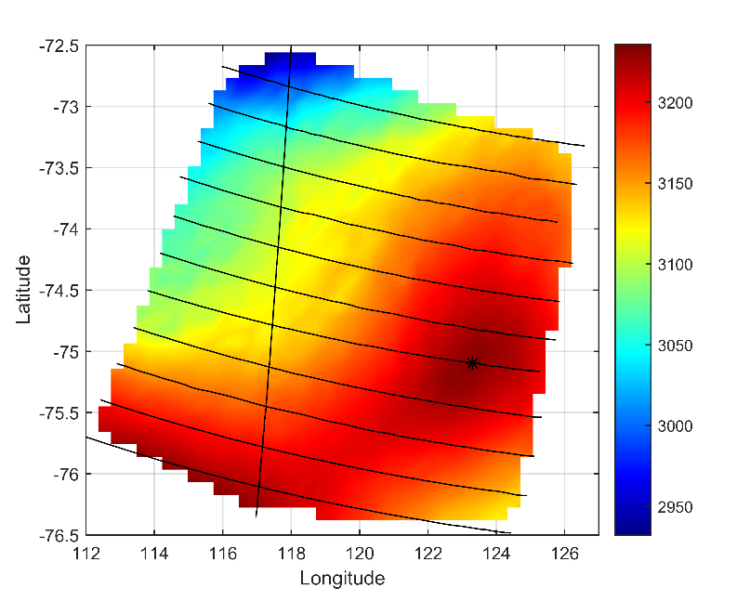
Figure 4-1: The 11 grid lines plus the tie line printed on a surface elevation map (note color scale in m). Concordia is marked with an asterisk.

The purpose of the campaign was to verify the spatial homogeneity of the Brightness Temperature, TB, in the area. The original assumption was that the penetration depth in the ice at L-band would be such that the prime contribution to the TB would be the cold and thermally stable ice some hundreds of m down – that is, no variations, either temporal or spatial. This would constitute a well-known and stable target for the calibration and inter-comparison of spaceborne L-band radiometer systems.
The calibrated TB data corresponding to the 12 straight flight lines have been interpolated (MATLAB function: griddata “natural”) in order to provide 2D imagery of the area: see Figure 4-2 as an example of side looking data. The dynamic range of TB in the plots is more than 10 K (around 205 – 215 K at V pol, 182 – 194 at H pol), and so it was immediately clear that the Dome C area does not present us with a uniform, homogeneous TB scene at the scale of observations (500 m).
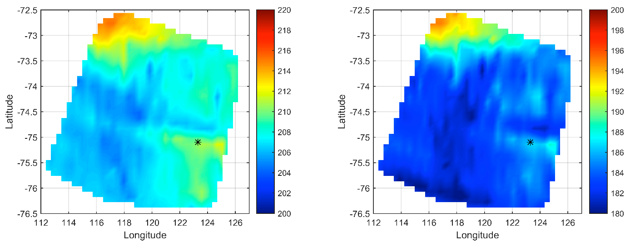
Figure 4-2: Side looking TB maps. V pol left, H pol right. Note TB scales in K.

Especially the northern part of the plots reveals a significant increase in TB. This can partly be ascribed to the fact that here, the surface begins to slope downwards towards the coast, meaning increased physical temperature and hence increased TB. See Figure 4-3 built on data from (Le Brocq et al., 2010), which shows that the average air temperature computed over decades (equal to the snow temperature 10 m below the surface, where the seasonal temperature swing is almost completely damped), rises by some 5 °C in the upper left part of the flight pattern area. The figure, however, also shows that the temperature is quite uniform over the lower and central parts of the flight pattern area.
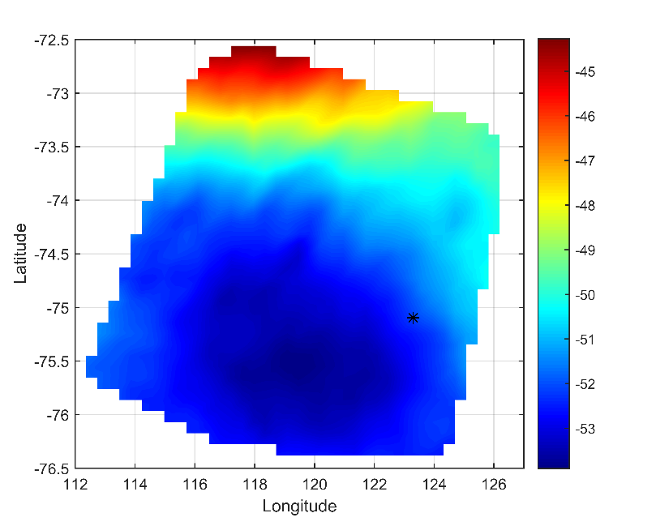
Figure 4-3: Map of the campaign area showing the temperature in °C at a depth of 10 m

Returning to Figure 4-2, we can obviously note large and different scale variations throughout the lower two-thirds of the map, where the surface is quite flat and the physical temperature is quite uniform.
The area around Concordia shows elevated TB. It seems that Concordia (indicated by an *) is situated on a brightness hilltop overlooking lowlands in most directions, particularly to the left in the figure. This naturally presents special challenges when comparing Concordia ground-based DOMEX data with DOMECair data and SMOS data.
In a quest for an explanation of the non-uniform TB image, a map of bedrock topography, taken from (Fretwell et al., 2013), is shown in Figure 4-4, together with nadir TB data.

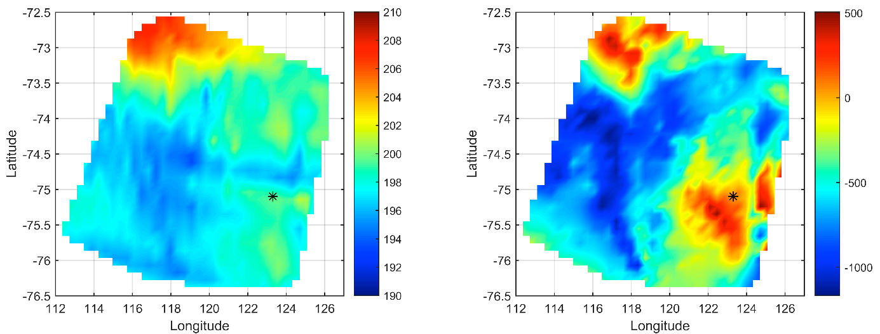
Figure 4-4: Nadir TB map (left) and bedrock below Concordia (right). TB in K, bedrock in m above sea level.
A convincing correlation is observed when comparing the two images: low brightness temperatures are generally seen over areas much below sea level (large ice thickness) while high brightness temperatures are associated with elevated areas above sea level (lesser ice thickness). This is further illustrated by the scatter plot in Figure 4-5, where the brightness temperatures from Figure 4-4 are plotted versus the bedrock elevation. Only data south of 74°S, where the physical temperature is quite uniform, are used. A linear regression line is shown, and the correlation coefficient is 0.504.
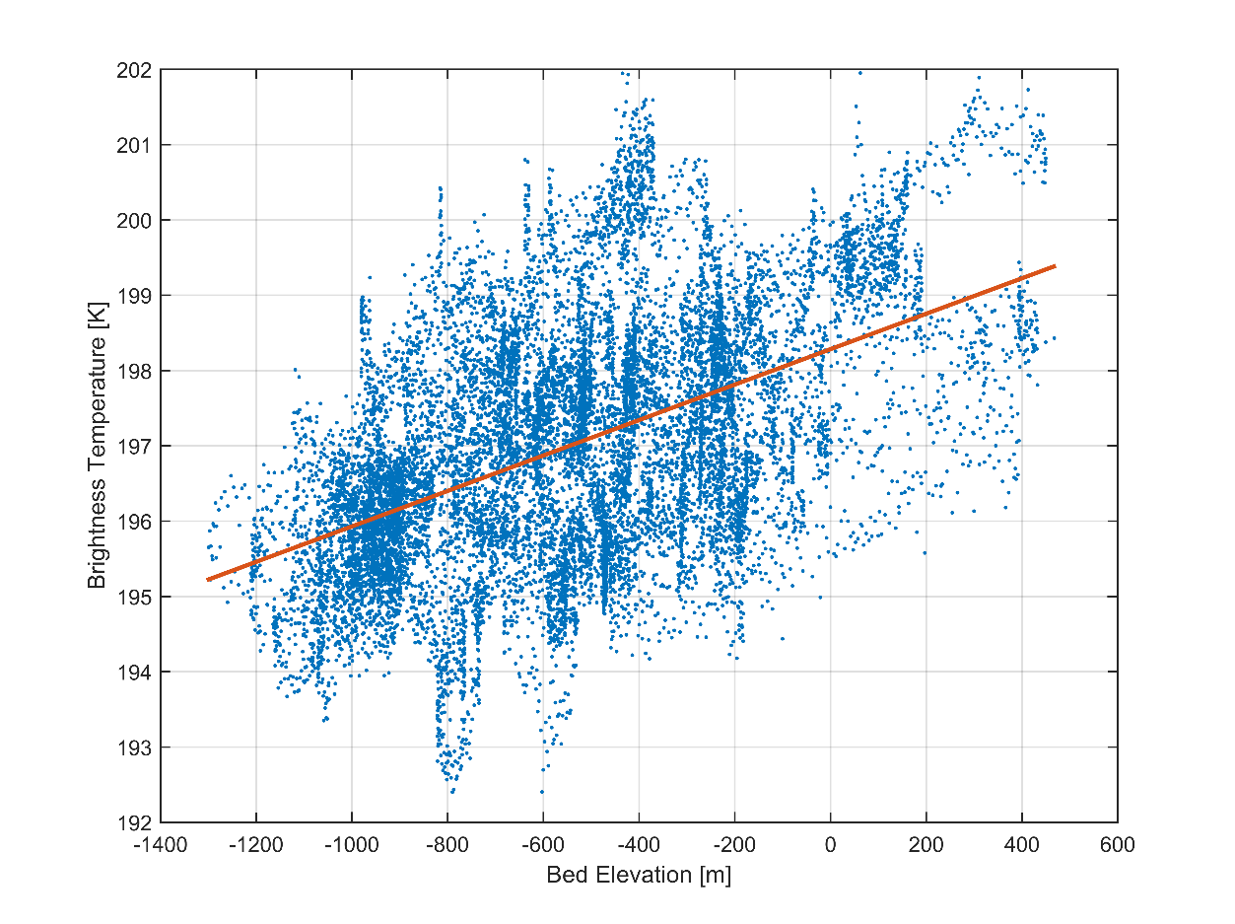
Figure 4-5: TB versus bedrock elevation.

The bedrock elevation in the area ranges from some -1000 m to about + 500 m, compared with sea level: i.e. the ice thickness varies by some 1500 m.
Therefore, the question is: can bedrock topography through some 3 km of ice (the surface is about 3000 m thick) affect the TB to the observed level?
As explained in (Jezek et al., 2015) and (Leduc-Leballeur et al., 2015) and also as pointed out in the D1 report, the brightness temperature of the internal part of the ice sheets depends mainly on the ice temperature profile. On the other hand, the temperature profile depends on several ice sheet parameters, the main two of which are the ice thickness (which, in turn, depends on bedrock elevation) and the accumulation rate. Moreover, the heat flux also influences the temperature profile. Other parameters, not related to the temperature profile, as for example surface or sub-surface properties, can modify the TB. However, these must be considered to be secondary effects that are responsible for temporal changes.
The results obtained in the DomeCAir experiment are fully in line with what has been demonstrated by theoretical models, and constitute a unique tool for a more thorough investigation of this topic, also by taking into account the higher resolution as compared with the to SMOS data.
For example, in Figure 4-6 the brightness temperature data from one of the lines of flight (Line5) is presented as a function of range. It is worth noting that Line 5 passes over the Concordia station at approximately x = 290 km.
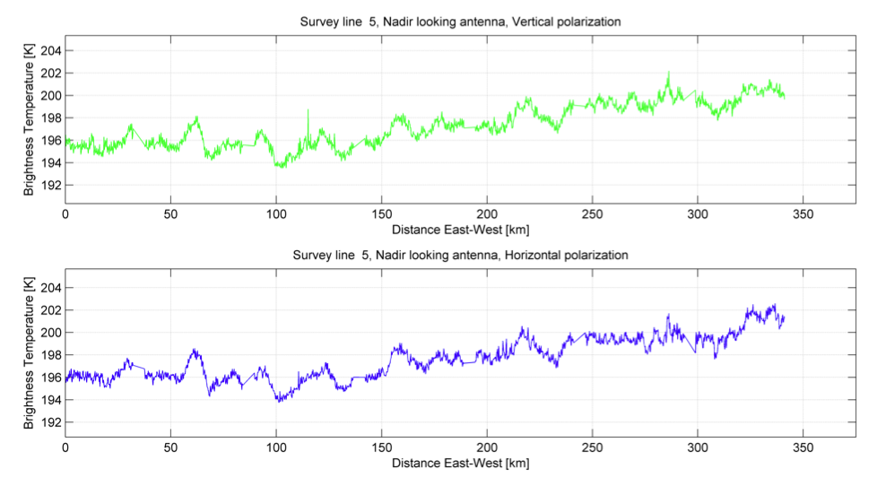
Figure 4-6 : Flight line 5 through Concordia.

In the figure it can be observed that, in spite of the general trend that increases from East to West and is mainly due to an increase in the surface temperature and to a decrease in ice thickness, the signal presents a significant number of fluctuations of around 2K at both Vertical and Horizontal polarization. This may be due to both the local bedrock topography and/or to the ice sheet properties. The scale of these fluctuations is on the order of 20 Km.
Preliminary results, which are presented in (Skou et al., 2013) and (Skou et al., 2014), demonstrated that a simple first-order transfer model, similar to the one presented in the D1 deliverable [RD.3] and which computes the ice sheet absorption starting from the ice sheet properties, is capable of explaining these data. Further investigations will continued in the present project by using more elaborated models.
We can conclude that bedrock topography greatly influences the temperature profile, and therefore affects the measured TB indirectly. This relationship will be further investigated in the present project in order to verify whether, by using appropriate models and auxiliary data, it will be possible to derive information from SMOS data on bedrock topography and heat flux.

Methodology
Based on what has been described above, the activity that will be conducted in the present Case Study will -as a first step- carry out an in-depth investigation of the data acquired during the DOMECair experiment, using models described in the D1 report. In particular, the following activities will be implemented:

- Measured TB will be correlated with the physical temperature of the ice sheet (Figure 4-3),
- The maps obtained will be compared with SMOS data,
- The DOMECair TB map will be compared with the gravity map,
- The data acquired will be simulated using the advanced model (DMRT-ML, Walomis, etc.).

As is quite obvious, this part of the activity will focus on the Dome C area where the data were collected. The last point, model simulations, will be fundamental in investigating the sensitivity to parameters that influence the TB and in developing a methodology to be used for the possible retrieval of ice sheet properties (i.e. bedrock topography, heat flux) in other parts of Antarctica.

The second step of the investigation concerns other areas of Antarctica. The activity will be developed as follows:
- SMOS and bedrock data will be compared over larger parts of Antarctica (coastal areas in which metamorphism is more relevant will be excluded as a first step),
- Comparisons will be made between SMOS and GOCE data (or others gravimetry data) over the same areas,
- Data will be also compared with SWARM magnetic data (Fox Maule et al., 2005) and with lithosphere models, in order to relate the TB variation to possible heat flux anomaly.

The potential product for Case No 2 is a topographic map of Antarctica. Bedmap2 already exists, but the validity of the data behind Bedmap vary greatly from area to area: some areas are densely covered by radio echo soundings, and thus quite are well known. But others, however, are not, and here a SMOS-based product can be of value. The said product will be based preliminarily on SMOS TB data that have been corrected for physical temperature at a depth of 10 m (Albmap) and augmented by GOCE data.

Potential constrains

Section 4.2 contains a discussion of how we can potentially retrieve information on bedrock topography from L-band brightness data in the area near Dome C. This area is characterized by scarce precipitation, considerable ice thickness, and very low ice flow: all in all, a very stable area. There is no reason to doubt that the findings there will also be applicable to a larger part of the interior of East Antarctica.
The main problem could be the lack of information that we have on other regions of the inner part of the continent, which could validate our approach. Theoretical models will be used in this case.
Moreover, when we analyze data collected near to coastlines and ice outlet areas, previous considerations of ice sheet stability fail and the applicability of the method that we intend to develop must be carefully verified. Moreover West Antarctica, where ice sheets have different properties, might present special challenges. All this will be investigated in a future work.

Case study n.3: characterization of ice shelves
(UHAM in cooperation with CESBIO)

Scientific challenge and requirements

As ice shelves float on water, their retreat of them contributes very little to the global sea level rise. However, a reduced buttressing of inshore glaciers is linked to increasing flow rates, and this in turn has a stronger impact on the mass balance and on the sea level. The lack of knowledge regarding the stability of ice shelves was visualized by the unexpected collapses of the Larson A and Larson B ice shelves in 1995 and 2002, respectively. Even though substantial progress has since been made, solid long-term estimates of ice shelves stabilities are not yet always possible. The sub-ice shelves circulation is influenced by far range oceanographic forcing, tidal activity, and the cavity geometry which interacts with melting and marine ice-formation processes. All these links and the role of the sub-ice shelves circulation in the formation of Antarctic bottom water are either inadequately understood or are based on only a few measurements, thus making them very difficult to quantify.
In order to improve the knowledge of ice shelves, in the present case study the possibility of retrieving three main geophysical parameters will be investigated, namely: A) the internal ice temperature, B) the shelf ice thickness, and C) the detection of basal marine ice. We emphasize the experimental character of this study as regards the great challenges relative to the problem of retrieval: 1) the coarse spatial resolution of SMOS field of view, 2) the relatively small scale of the shelf ice areas, 3) the vicinity of coastal polynyas and their large variability, 4) the sparseness or total absence of suitable validation measurements, and 5) the ill-posed character of the inverse retrieval problem.
Since only very few if any in-situ measurements of the shelf ice temperature are available, we have to rely mainly on model simulations. Temperature profiles can be obtained from 3D full-stoke simulations such as those of Nina Wilkens (2014). The model has been set up for the Pine Island Glacier (PIG) and shelf system. Although the PIG shelf is relatively small (just one SMOS footprint), its simulated temperature profiles can be used for a theoretical sensitivity study in order to assess the vertical resolution of an ice temperature retrieval. Synthetic profiles will be derived from linear combinations of three distinct profiles. The said synthetic profiles will be used to evaluate the consistency and sensitivity of retrieval algorithms, using a forward radiative transfer model.
The Ross and Ronne-Filchner ice shelves are large enough to test the retrieval with real SMOS data (see preliminary data overview in the following section). In order to derive information on the vertical profile, we will use TB measurements at different incidence angles. A preliminary analysis using a simple radiative transfer model for a profile, with ice surface temperature at T=-15°C and the basal temperature at T=-2°C, suggests that the signal is saturated at a depth of about 500 m for a shallow incidence angle of 60°. Measurements at steeper near-nadir angles carry information from layers deeper than 500 m. The set of polarized measurements at different incidence angles form an inverse problem for the retrieval. Similar to the case of atmospheric temperature sounding this problem could be solved by using the optimal estimation method (Rodgers, 1976). Another potential approach is a minimization technique developed by Mironov (2013) for the retrieval of temperature gradients in frozen soil. The degrees of freedom (i.e. vertical resolution) will be analyzed, together with what a-priori information or boundary conditions (e.g. surface temperature) are required to constrain the inverse problem.

The characterization of ice shelves: test areas, data and methodologies

The key areas for the investigation are primarily the two largest ice shelves, i.e. Ronne-Filchner and Ross, as well as Larsen, Fimbulisen, Amery and PIG (Figure 5-1).

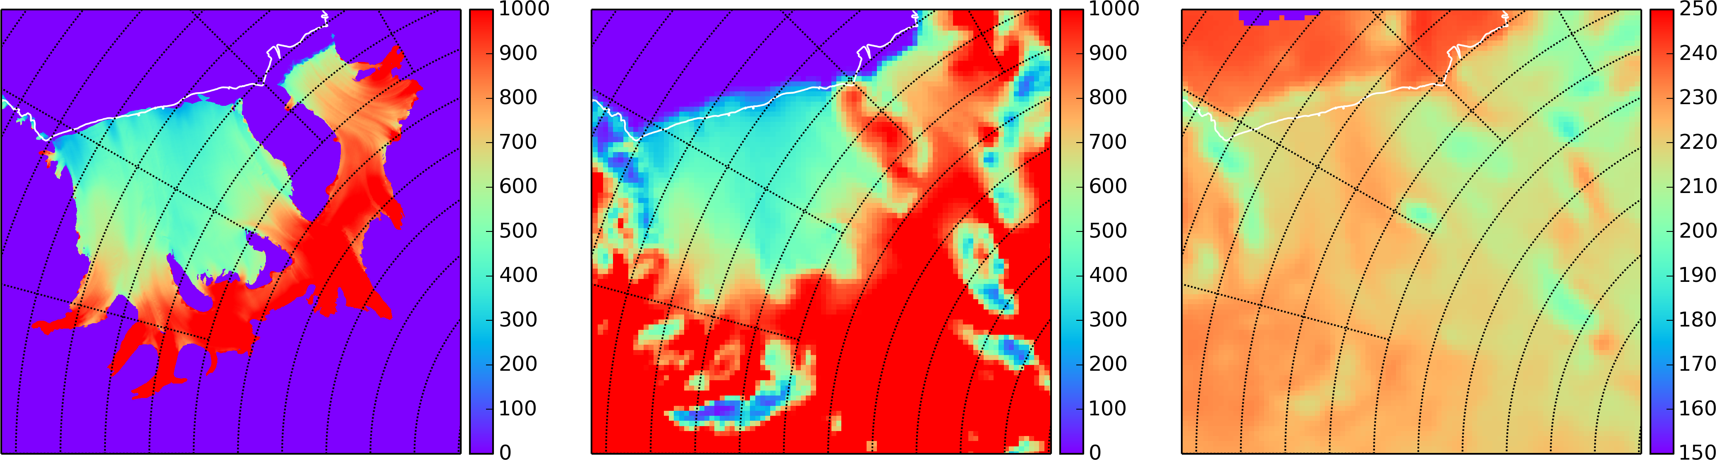Figure 5-1a: Ronne-Filchner
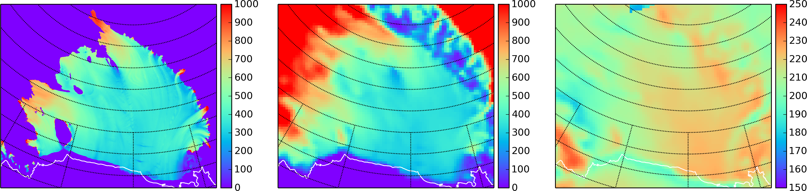Figure 5-1b: Ross
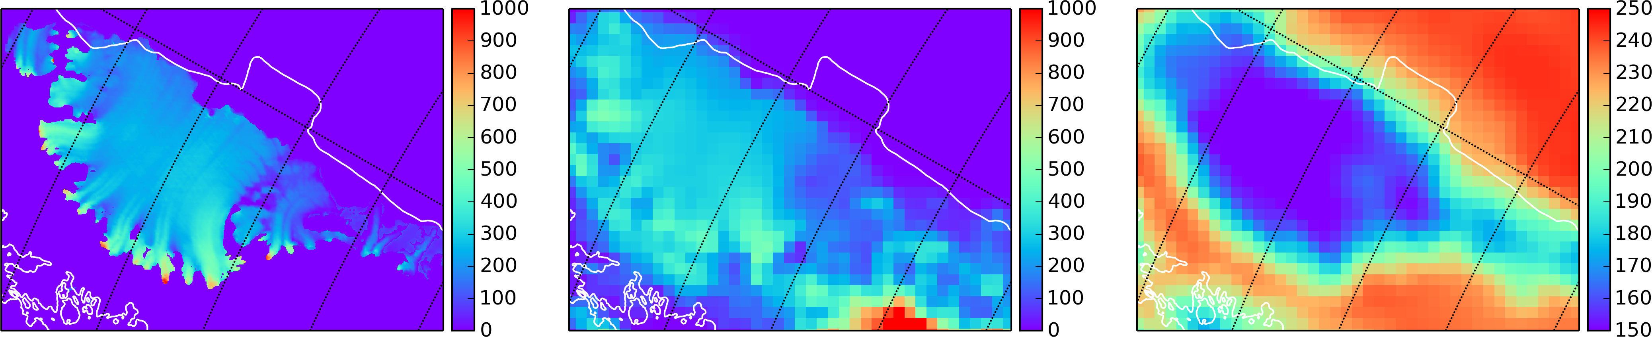Figure 5-1c: Larsen
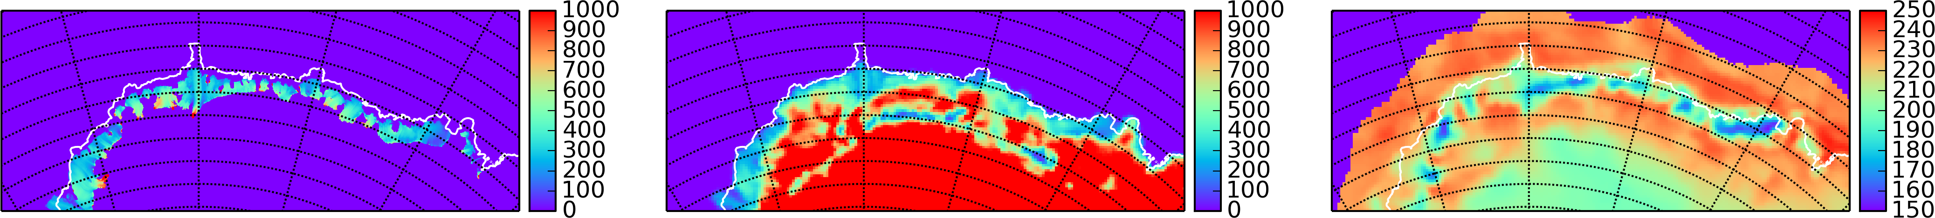Figure 5-1d: Fimbulisen
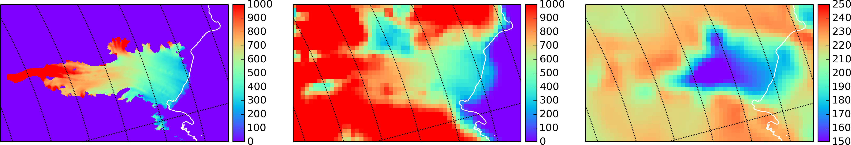Figure 5-1e: Amery
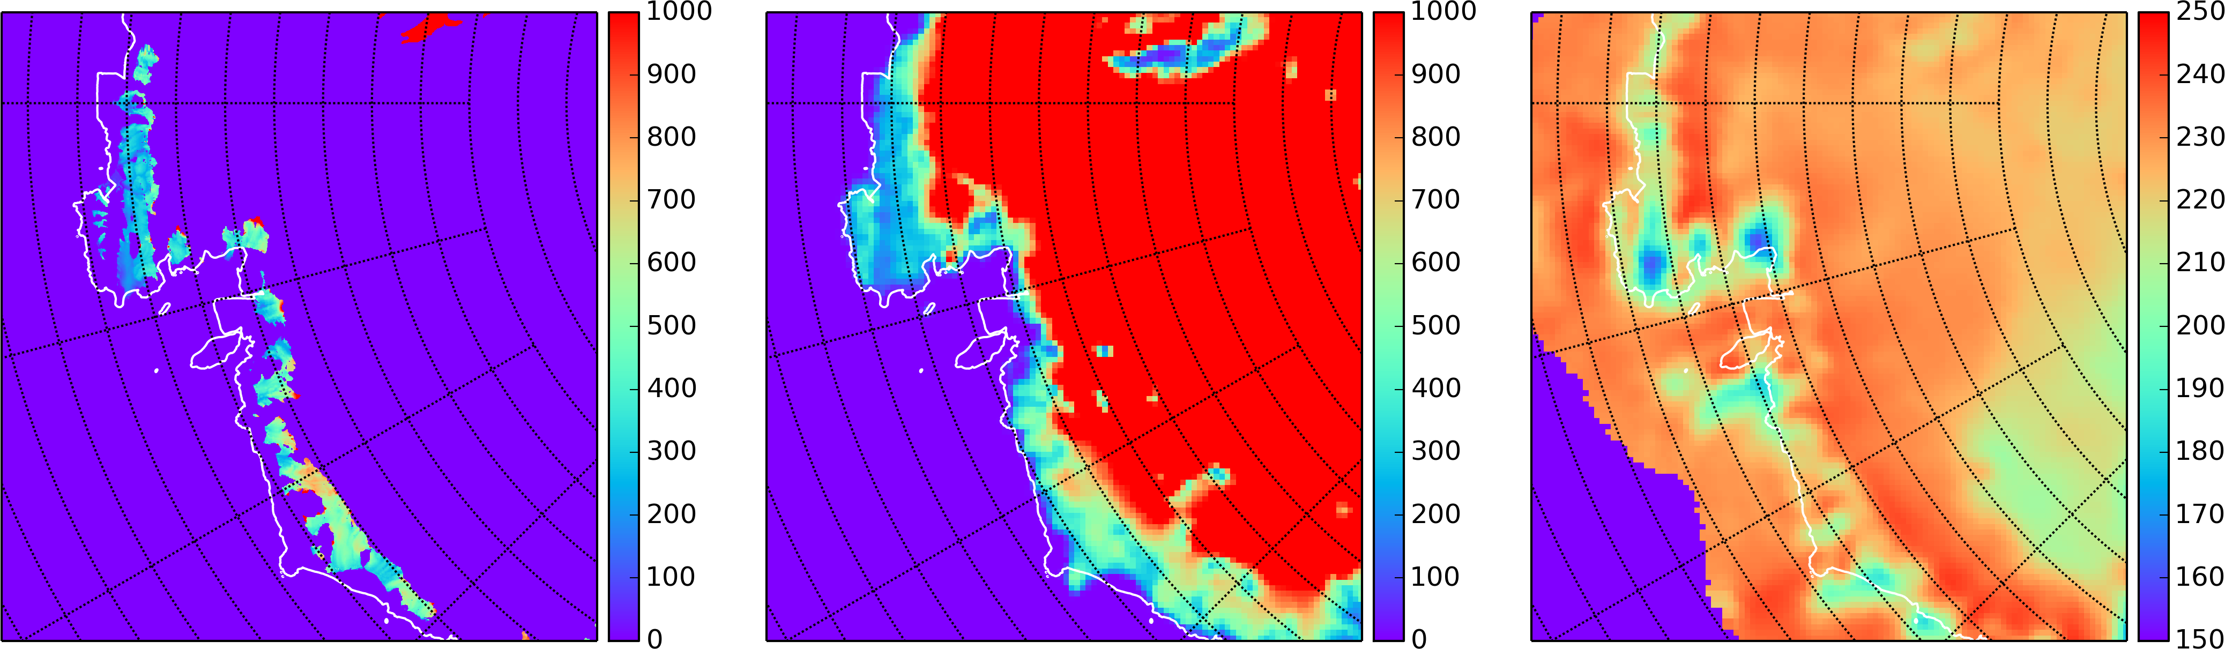Figure 5-1f: PIG
Figure 5-1: Images (from left to right): ice shelf thickness of Deeporter et al. (2013), ice thickness (height-draft) from RTopo interpolated on 12.5 km grid, SMOS brightness temperature on 12.5 km grid.

The following datasets are expected to be needed and, to be sufficient, during the course of this venture: SMOS brightness temperatures; Surface temperature (e.g. from MODIS), ice shelf thickness or freeboard (e.g. Timmermann et al., 2010; Deeporter et al., 2013, Helm et al., 2014). Optional (if not available in digital format: qualitative comparison with published data): Marine ice thickness (RES and borehole) and temperature profiles (borehole).

Methodologies
Empirical data analysis: The SMOS data can already provide valuable information about the inherent information and their limitations. The mean, standard derivation, trends and seasonal cycle will be analyzed. We expect a shift from a very small seasonal cycle in the south to increased values in the northern regions, since larger surface liquid water contents can occur in summer, having strong influences on the SMOS data. We will develop a detection method based on only SMOS data or in combination with surface temperature data in order to classify areas that exhibit a distinct seasonality. Brightness temperatures will be correlated with available shelf ice thickness data.
Development of a forward model: A simple forward model serves as a basis for the inversion, and can exhibit the sensitivities of the SMOS brightness temperature to the parameters involved.
Tasks: Definition and implementation of an electromagnetic loss model (e.g. based on Mätzler, 2006) ; Definition of an incidence-angle-dependent brightness temperature model ; Derivation of annual mean surface temperature as boundary condition (e.g. MODIS). The bottom temperature can probably be approximated at the pressure freezing point ; Implementation of an ice thickness grid as an auxiliary boundary condition ; Definition of Temperature Profile Function ; Implementation of a marine ice layer e.g. with constant temperature and electromagnetic properties (Craven et al., 2009; +1 free parameter (thickness)) ; Sensitivity study (observational angle, temperatures at boundaries, thicknesses, temperature profile function parameters) (1 month)
Inversion: The model is numerically inverted in order to retrieve temperature profiles from SMOS data.
Tasks: Selection and implementation of a numerical inversion Method. The most appropriate method depends on the information content in the SMOS data and on the amount of non-linearity of the model.
Validation: The internal consistency and sensitivity to assumptions and boundary conditions of the final product will be analyzed in order to derive an error estimate.
Tasks: Investigation into what extent prescribed parameters can be reproduced ; Validation with independent measurements: Comparison of retrieved profiles with temperatures and marine ice thickness (if available) from borehole measurements ; Marine ice thickness maps from Radio Echo Sounding (RES) and surface altimetry. RES is expected to show the meteorological/marine ice interface. The combined-ice sheet thickness is derived from the surface altitude in combination with estimates of the sea surface height and isostasy. It might be necessary to consider the influence of unconsolidated marine ice (roughly 1/2 of the marine ice layer (Craven et al., 2009), since we expect the embedded water to dominate the signal from this depth.

Potential constraints
Due to the experimental nature of this investigation, it is not yet possible to state exactly which results can be delivered. To account for this, we have separated the results into three classes.

(1) Certain:
- Estimation of the areas influenced by surface melting,
- Maps of TB seasonal cycles and potential trends,
- Report on empirical data analysis,
- Forward model and retrieval scheme tested using synthetic data,
- Report on sensitivities.

(2) Uncertain:
- Retrieval of shelves ice temperature (profiles),
- Detection of marine ice layers ,
- Retrieval of shelves ice thickness (trends).

(3) Unexpected:
Within the progress of this venture, it could happen that more information will be extracted than expected (e.g. the thickness of the marine ice layer), or that other properties will play an important role which has not been properly considered (e.g. variations in the surface or bottom roughness).

Case study n.4: characterization of surface processes
(LGGE in cooperation with IFAC, CESBIO)

Scientific challenge and requirements

The state of the surface is essential to understanding and predicting the surface energy and mass budgets, which are two key nivo-meteorological variables of interest for the study of the climate and as a contribution to the sea level of ice-sheets. Snow properties such as grain size, wetness, density, and roughness are linked to air temperature, surface wind, precipitations, etc., which are important in helping climate models to retrieve surface processes and to monitor climate change. SMOS observations could help to detect fresh snow in order to supply information about precipitations, to follow variations in roughness linked to wind, as well as monitor melting periods (number of melting days per year, duration, starting date, etc.). Thanks its large penetration depth, SMOS observations could detect whether melt is deep and impacts on snowpack stability, contrary to higher microwave frequencies, which are sensitive to the first meters of snowpack.
A first preview of SMOS observations has shown that two main regions can be identified and will have to be explored separately (see Figure 4 in [RD.3]). One, in the internal part of the continent, is a region in which the ice sheet is always dry. The L-band brightness temperature is very stable, and any small variations observed could be interpreted as changes in the surface state. For example, we used a rough simulation with the WALOMIS model to show the sensitivity of e.m. emission to variations in the density of a thin snow layer on the surface at the Dome C test site.
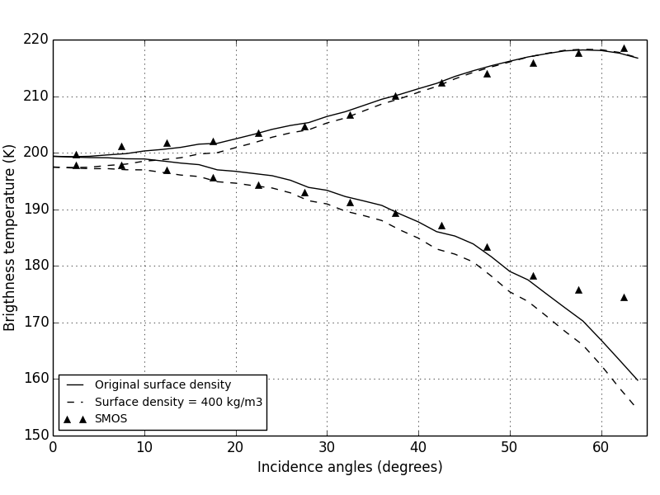
Figure 6-1: TB simulations at 1.4 GHz at Dome C (75°S, 123°E) performed with measured density profiles (solid line) and with a surface layer 3 cm thick characterized by a density of 400 kg m-3 (dotted line). SMOS observations from 2010 and 2013 were averaged by 5° incidence angle steps (triangles).

Figure 6-1 shows simulated TB at vertical (V) and horizontal (H) polarizations performed with: 1) in situ measurements of density profiles; 2) same as 1) but with a surface layer of 3cm characterized by density larger than the measured one (400 kg m-3). As a result, brightness temperature decreases by about 2 K at 0° incidence angle at both polarizations. However, the brightness temperature decreases by about 4 K at 55° incidence angle in H polarization, but is weakly affected at V polarization (almost 0 K at 55°). This may indicate that a change in surface density affects brightness temperature at L-band, particularly at H polarization. Thus, surface processes resulting in density, grain size, etc. variations can be potentially identified from SMOS observation variations.
The second region is the wet snow area, which is located mainly along the coast and on ice-shelves. Here, the surface state is affected by seasonal melting events that considerably influence the snowpack. Indeed, the episodic presence of liquid water forms a refrozen snow layer and leads to a sustained decrease in the L-band brightness temperature observation after the melt season as compared to before the melt season. Moreover, annual snow accumulation is greater than in a in dry snow region. For these reasons, surface processes along the coast and ice-shelves are expected to be different from the internal ice-sheet. Thus, SMOS observations in this region could help to follow and characterize surface melting events.

The characterization of surface processes: test areas, data and methodologies

In a dry snow region, the first objective will be an accurate characterization of the effect of the surface state on SMOS observations at Dome C. A recent work by Brucker et al. (2014a) using Aquarius L-band observations shows a significant variation in the TB H/V ratio. This ratio makes it possible to remove the dependence on the physical temperature of the emitting ice-sheet medium, and highlights the variations in the H and V emissivities. The authors explain some variations in the TB H/V ratio as being due to hoar on the surface. However, the origins of these variations are not completely understood. Thus, our main objective will be to investigate the TB H/V ratio variations and to link them it to snow properties near the surface, in particular to surface density. To do that, numerous in situ measurements of snow properties performed at Dome C will be used, as well as satellite observations, such as AMSR-E, AMSU and SSM/I.
In a second time, from results obtained at Dome C, electromagnetic modeling suggested in D1 [RD.3] (DMRT-ML, WALOMIS) will be used to extend our understanding to the whole Antarctic ice-sheet.
In a wet snow region, the main objective is to characterize seasonal melt/freeze events. Sensitivity to these events has been clearly shown by Brucker et al., (2014), who observed a ~5 K decrease in Aquarius TB at horizontal polarization in Greenland after the unusually widespread melt events in 2012 (which took place over the entire ice sheet). In the same way, Figure 6-2 shows SMOS TB at H polarization collected over the Queen Maud Land region with the days of melt superimposed. These days of melt were retrieved from SSM/I microwave observations. A clear increase in TB of about 80 K was observed during melt season from January to March. As pointed out by Brucker et al., (2014), after the melt event the TB seemed about 5 K colder than before. This signal suggests that SMOS observations could provide information about on the melt intensity or the thickness of ice sheet affected by melting. Moreover, a shift was observed between the increase in SMOS TB and the days of melt identified by Picard et al., (2006) with SSM/I (green points on Figure 6-2). This method used a 19 GHz channel, which is representative of the first meter of snowpack, whereas SMOS can take into account a larger part and thus a better-defined melting period. Thus, SMOS TB will be analyzed in conjunction with higher-frequency satellite observations (SSM/I, AMSU and AMSR2) in order to determine whether refrozen liquid water influences surface only, or penetrates into the snowpack as well as to obtain information about the beginning of melt and its duration. In this way, focus will be placed on SMOS TB horizontal polarization in order to retrieve information on surface density. In a first time, analyses will be conducted on Ronne or Ross ice-shelves in order to benefit from a vast melting area.
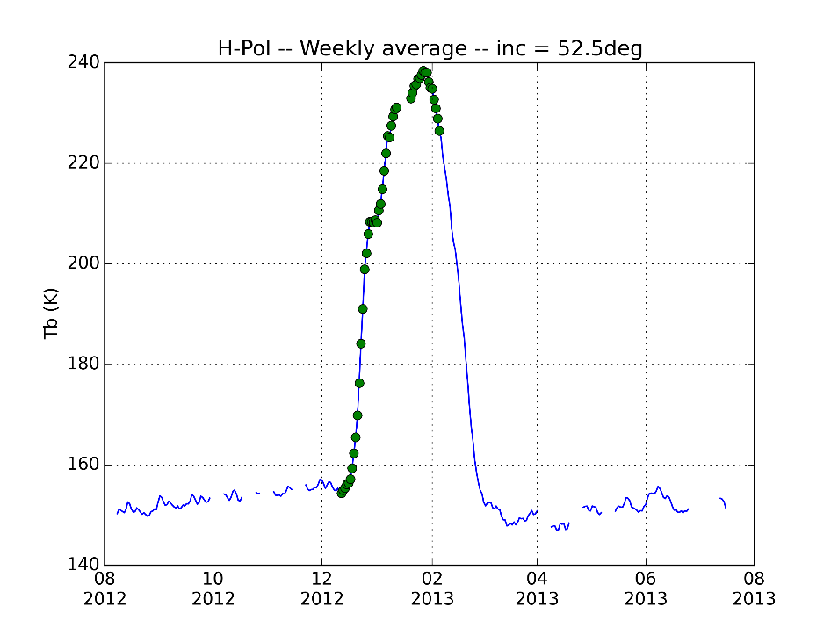

Figure 6-2: SMOS L3 TB at H polarization for 52.5° of incidence angle from August 2012 to July 2013 in the coastal region (in Queen Maud Land near 70°S, 30°E). Green points are days detected as days of melt by Picard et al., (2006) produced from higher-frequency satellite observations.

Potential constrains

Two main constraints can be appeared. First, although recent works have provided a better understanding on how to simulate L-band signal in Antarctica, its modeling is in the early stages. Thus, the different models should be use with caution, in particular when we have no in situ measurements to drive simulation or in regions where bedrock can contributed to SMOS signal (i.e. where the snowpack is thicker than the penetration depth).
The second constraint comes from the lack of snow properties in in-situ measurements. Indeed, building a reliable product over the entire Antarctic continent (e.g. surface density) will be difficult because very few measurements are available for performing the validation everywhere.

References

Bereiter, B., H. Fischer, J. Schwander, and T. F. Stocker, “Diffusive equilibration of N2, O2 and CO2 mixing ratios in a 1.5 million years old ice core”, The Cryosphere Discuss., 7, 2029-2060, 2013.
Brogioni M., S. Pettinato, F. Montomoli, K.C. Jezek , G. Macelloni, “Simulating multi-freqeuncy ground based radiometric measurements at Dome C - Antarctica”, submitted to IEEE Journal Of Selected Topics In Applied Earth Observations And Remote Sensing, 2015
Brucker L., Dinnat E.P., Picard G., Champollion N., “Effect of Snow Surface Metamorphism on Aquarius L-Band Radiometer Observations at Dome C, Antarctica” , IEEE Transactions on Geoscience and Remote Sensing, 52(11): 1-10, doi: 10.1109/TGRS.2014.2312102 , 2014a
Brucker L., Dinnat E. P., Koenig L. S., “Weekly gridded Aquarius L-band radiometer/scatterometer observations and salinity retrievals over the polar regions – Part 2: Initial product analysis”, The Cryosphere, 8:915-930, www.the-cryosphere.net/8/915/2014, doi:10.5194/tc-8-915-2014, 2014b
Cook A. J. and Vaughan D.G., “Overview of areal changes of the ice-shelves on the Antarctic Peninsula over the past 50 years”, The Cryosphere, 4(1), 77-98, 2010
Craven M. et al., “Properties of a marine ice layer under the Amery Ice Shelf, East Antarctica”, Journal of Glaciology, 55.192, pp. 717-728, 2009
Cuffey K.M. and W.S.B. Paterson, “The physics of glaciers”, Academic Press, 2010
Depoorter M. A., J. L. Bamber, J. A. Griggs, J. T. M. Lenaerts, S. R. M. Ligtenberg, M. R. van den Broeke and G. Moholdt, “Calving fluxes and basal melt rates of Antarctic ice shelves”, Nature, doi:10.1038/nature12567, 2013
Dupont F., Picard G., Royer A., Fily M., Langlois A., Roy A., Champollion N., “Modeling the microwave emission of bubbly ice; Applications to blue ice and superimposed ice in the Antarctic and Arctic”, IEEE Transactions on Geoscience and Remote Sensing, in press.
Fox Maule C., Purucker M., Olsen N., Mosegaard K., “Heat flux anomalies in Antarctica revealed from satellite magnetic data”, Science, Vol. 309, No. 5733, 2005, p. 464-467
Fretwell et al. (2013):“Bedmap2: improved ice bed, surface and thickness datasets for Antarctica”, The Cryosphere, 7, 375-393, http://www.the-cryosphere.net/7/375/2013/tc-7-375-2013.pdf
Helm V., Humbert A. and Miller H., “Elevation and elevation change of Greenland and Antarctica derived from CryoSat-2”, The Cryosphere, 8, 1539-1559, doi:10.5194/tc-8-1539-2014, 2014
Jezek K. C., J. T. Johnson, M. R. Drinkwater, G. Macelloni, L. Tsang, M. Aksoy, and M. Durand (2015):
“Radiometric Approach for Estimating Relative Changes in Intraglacier Average Temperature”
IEEE Trans. on Geoscience and Remote Sensing, Vol. 53, No. 1, pp 134-143.
Kristensen, S. S., S.S. Søbjærg, J. E. Balling and N. Skou, “DOMECair Campaign, EMIRAD Data: Presentation and Analysis”, DTU Space report, 12/11 – 2013, 118 p.
Kaleschke L., Maaß N., Haas C., Hendricks S., Heygster G. and Tonboe R. T., “A sea-ice thickness retrieval model for 1.4 GHz radiometry and application to airborne measurements over low salinity sea-ice”, The Cryosphere, 4, 583-592, doi:10.5194/tc-4-583-2010, 2010
Kaleschke et al., “Sea ice thickness retrieval from SMOS brightness during the Arctic freeze-up period”, Geophys. Res. Lett., 39, L05501, 2012
Kaleschke L., X. Tian-Kunze, N. Maaß, M. Mäkynen, and M. Drusch (2012), “Sea ice thickness retrieval from SMOS brightness temperatures during the Arctic freeze-up period”, Geophys. Res. Lett., doi:10.1029/2012GL050916
Leduc-Leballeur M., Picard G., Mialon A., Arnaud L., Lefebvre E., Possenti P., Kerr Y., “Modeling L-band brightness temperature at Dome C, Antarctica and comparison with SMOS observations”, IEEE Transactions on Geoscience and Remote Sensing, 2015, in press
Le Brocq A. M., A.J. Payne, and A. Vieli, “An improved Antarctic dataset for high resolution Geography numerical ice sheet models (ALBMAP v1)”, Earth Syst. Sci. Data, 2, 247-260, www.earth-syst-sci-data.net/2/247/2010/, doi:10.5194/essd-2-247-2010.
Macelloni G., M. Brogioni, S. Pettinato, R. Zasso, A. Crepaz, J. Zaccaria, B. Padovan, and M. Drinkwater (2013): “Ground-Based L-Band Emission Measurements at Dome-C Antarctica: The DOMEX-2 Experiment”, IEEE Trans. on Geoscience and Remote Sensing, Vol. 51, No. 9, pp 4718-4730.
Maaß N., Kaleschke L., Tian-Kunze X., Mäkynen M., Drusch M., Krumpen T., Hendricks S., Lensu M., Haapala J. and Haas C., (2015), “Validation of SMOS sea ice thickness retrieval in the northern Baltic Sea”, Tellus A, 67. doi:http://dx.doi.org/10.3402/tellusa.v67.24617
Macelloni G., M. Brogioni, P. Pampaloni, A. Cagnati, and M.R. Drinkwater, “DOMEX 2004: An experimental Campaign at Dome-C Antarctica for the Calibration of Space-Borne Low–Frequency Microwave Radiometers”, IEEE Trans. Geosci. and Remote Sens., 44, 10, 2642 – 2653, 2006.
Macelloni G., Brogioni M., Aksoy M., Johnson J.T., Jezek K.C., Drinkwater, M.R., “Understanding SMOS data in Antarctica”, Geoscience and Remote Sensing Symposium (IGARSS), 2014 IEEE International, DOI: 10.1109/IGARSS.2014.6947263, 2014 , pp. 3606 – 3609

Macelloni G., M. Brogioni, S. Pettinato, R. Zasso, A. Crepaz, J. Zaccaria, B. Padovan, M. Drinkwater, "Ground-Based L-Band Emission Measurements at Dome-C Antarctica: The DOMEX-2 Experiment", IEEE Trans. On Geoscience and Remote Sensing, Vol.51, n.9, pp. 4718 - 4730, Sep. 2013, DOI:10.1109/TGRS.2013.2277921
Mätzler, C. (2001): “Application of SMOS over Terrestrial Ice and Snow”, 3rd SMOS Workshop, DLR, Germany, December 10-12, 9p.
Mätzler C., “Microwave dielectric properties of ice”, Thermal microwave radiation: applications for remote sensing, Institute of Engineering and Technology, Stevenage, U. K., Vol. 52. pp. 455-462
Mironov V.L. et al., (2013), “Retrieving Temperature Gradient in Frozen Active Layer of Arctic Tundra Soils From Radiothermal Observations in L-Band - Theoretical Modeling”, IEEE Journal Of Selected Topics In Applied Earth Observations And Remote Sensing, Vol. 6, No. 3, June 2013
Oerlemans J. and C. J. van der Veen, “Ice sheets and climate”, Vol. 21. No. 7. Dordrecht: Reidel, 1984
Parrenin F., G. Dreyfus, G. Durand, S. Fujita, O. Gagliardini, et al. “Ice flow modelling at EPICA Dome C and Dome Fuji, East Antarctica”, Climate of the Past Discussions, European Geosciences Union (EGU), 2007, 3 (1), pp.19-61.
Rignot E., Velicogna I., van den Broeke M. R., Monaghan A., Lenaerts J. T. M., 2011, “Acceleration of the contribution of the Greenland and Antarctic ice sheets to sea level rise”, Geophys. Res. Lett., 38, L05503
Ritz C., “Interpretation of the temperature profile measured at Vostok, East Antarctica”, Annals of glaciology, n.12, 1989
Robin G. de Q., “Ice movement and temperature distribution in glacier and ice sheets”, Journal of glaciology, 2, 523-532
Scambos T. A., Bohlander J. A., Shuman C. A., Skvarca P., 2004, “Glacier acceleration and thinning after ice-shelf collapse in the Larsen B embayment, Antarctica”, Geophys. Res. Lett., 31, L18402.
Scambos T., “NASA-USGS Landsat 8 Satellite Pinpoints Coldest Spots on Earth”,2013 NASA Headquarters release No. 13-364
Skou, N., S. S. Kristensen, , S. S. Søbjærg, and J. Balling (2013): “DOMECair: An Airborne Campaign in Antarctica Supporting SMOS Calibration” Proceedings ESA Living Planet Symposium, Edinburgh, September 2013, 8p.
Skou, N., S. S. Kristensen, S. S. Søbjærg, and J. Balling, “Mapping of the Dome-C Area in Antarctica by an Airborne L-band Radiometer”, Proceedings of IGARSS 2014, July 2014, pp 3610 – 3613
Søbjærg et al., “DomeCAir C Campaign: EMIRAD Data: Presentation and Analysis”, ESA Final Report.
Steig E. J., Schneider D. P., Rutherford S. D., Mann M. E, Comiso J. C, Shindell D. T., 2009, “Warming of the antarctic ice-sheet surface since the 1957 international geophysical year”, Nature, 457, 459-462.
Tabacco I.E., C. Bianchi, M. Chiappini, A. Passerini, A. Zirizzotti and E. Zuccheretti “Latest improvements for the echo sounding system of the Italian radar glaciological group and measurements in Antarctica”, Annals of Geophysics, 42, (2), 1999
Tan S., Aksoy M., Brogioni M., Macelloni G., Durand M., Jezek K., Wang T., Tsang L., Johnson J., Drinkwater M., Brucker L., “Physical Models of Layered Polar Firn Brightness Temperatures from 0.5GHz to 2GHz”, IEEE Journal of Selected Topics in Applied Earth Observations and Remote Sensing, vol. -, n. -, pp. -, 2015, doi: 10.1109/JSTARS.2015.2403286
Tara J., Domack E. W., Dutrieux P., Galton-Fenzi B., Hellmer H. H., Humbert A., Jansen D., Jenkins A., Lambrecht A., Makinson K., Niederjasper F., Nitsche F.-O., Nøst O. A., Smedsrud L. H., Smith W., (2010) “A consistent dataset of Antarctic ice sheet topography, cavity geometry, and global bathymetry” Earth System Science Data, 2(2), 261-273, doi:10.5194/essd-2-261-2010
Timmermann, R et al. (2010) “Antarctic ice sheet topography, cavity geometry, and global bathymetry” (RTopo 1.0.5-beta). doi:10.1594/PANGAEA.741917, Supplement to: Timmermann R. et al. “A consistent dataset of Antarctic ice sheet topography, cavity geometry, and global bathymetry”, Earth System Science Data, 2(2), 261-273, doi:10.5194/essd-2-261-2010
Tian-Kunze X., Kaleschke L., Maaß N., Mäkynen M., Serra N., Drusch M., and Krumpen T., ”SMOS-derived thin sea ice thickness: algorithm baseline, product specifications and initial verification”, The Cryosphere, 8, 997-1018, doi:10.5194/tc-8-997-2014, 2014.
Tsang L. and J.A. Kong, “Scattering of Electromagnetic Waves, Vol. 3: Advanced Topics”, Wiley Interscience, 2001, 413 pages.
Turner J., Lachlan-Cope T. A., Colwell S., Marshall G. J., Connolley W. M., 2006, “Significant warming of the Antarctic winter troposphere”, Science, 311, pp. 1914–1917
Van der Veen C.J., “Fundamentals of Glacier Dynamics”, CRC Press, 2013

